Dev Dependencies
# Source: AI Source: Provided by: [Data Path: Persons Table -> ID Column: 1, Name_En Column: Motasem Essam] -> From: [Chatgpt (GPT‑5 Mini)] on [1/26/2026]
Dev Dependencies (short for Development Dependencies) are the packages or libraries that a project needs only during development and testing, not in production.

📦 In PHP (Composer), Node.js (npm), Python (pip), etc.
# Source: AI Source: Provided by: [Data Path: Persons Table -> ID Column: 1, Name_En Column: Motasem Essam] -> From: [Chatgpt (GPT‑5 Mini)] on [1/26/2026]
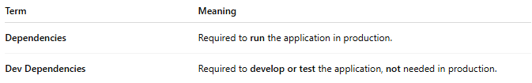
Term | Meaning
Dependencies | Required to run the application in production.
Dev Dependencies | Required to develop or test the application, not needed in production.

✅ Examples of Dev Dependencies

In a PHP project (composer.json)
# Source: AI Source: Provided by: [Data Path: Persons Table -> ID Column: 1, Name_En Column: Motasem Essam] -> From: [Chatgpt (GPT‑5 Mini)] on [1/26/2026]
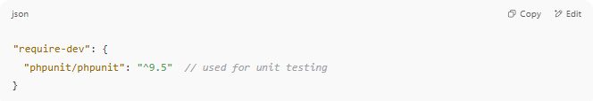
"require-dev": {
"phpunit/phpunit": "^9.5" // used for unit testing
}

In a Node.js project (package.json)
# Source: AI Source: Provided by: [Data Path: Persons Table -> ID Column: 1, Name_En Column: Motasem Essam] -> From: [Chatgpt (GPT‑5 Mini)] on [1/26/2026]
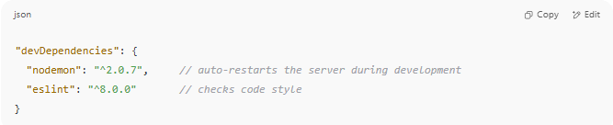
"devDependencies": {
"nodemon": "^2.0.7", // auto-restarts the server during development
"eslint": "^8.0.0" // checks code style
}

⚙️ Use Cases
# Source: AI Source: Provided by: [Data Path: Persons Table -> ID Column: 1, Name_En Column: Motasem Essam] -> From: [Chatgpt (GPT‑5 Mini)] on [1/26/2026]
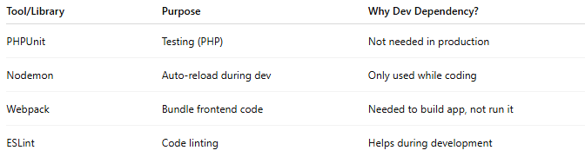

Tool/Library | Purpose | Why Dev Dependency?
PHPUnit | Testing (PHP) | Not needed in production
Nodemon | Auto-reload during dev | Only used while coding
Webpack | Bundle frontend code | Needed to build app, not run it
ESLint | Code linting | Helps during development

📌 Why separate them?
# Source: AI Source: Provided by: [Data Path: Persons Table -> ID Column: 1, Name_En Column: Motasem Essam] -> From: [Chatgpt (GPT‑5 Mini)] on [1/26/2026]
- ✅ Smaller production size
- ✅ Faster deployment
- ✅ Better security (fewer packages = fewer risks)

